Vector Autoregression (VAR) is a forecasting algorithm that can be used when two or more time series influence each other. The relationship between the time series involved is bi-directional.  
Vector Autoregression is a multivariate forecasting algorithm that is used when two or more time series influence each other. The basic requirements in order to use VAR are:

-You need at least two time series (variables)  
 -The time series should influence each other.

It is considered as an Autoregressive model because each variable (Time Series) is modeled as a function of the past values; predictors are nothing but the lags (time delayed value) of the series.

A typical Autoregression model formula: 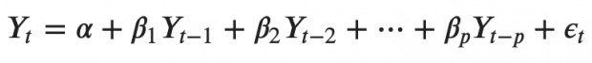

α is the intercept; β1, β2 till βp are the coefficients of the lags of Y till order p. Order ‘p’ means, up to p-lags of Y is used and they are the predictors in the equation. The ε_{t} is the error, which is considered as white noise.  
In the VAR model, each variable is modeled as a linear combination of past values of itself and the past values of other variables in the system. Since you have multiple time series that influence each other, it is modeled as a system of equations with one equation per variable (time series). If you have 5 time series that influence each other, we will have a system of 5 equations.

Example:  
Suppose you have two variables (time series) Y1 and Y2 and you need to forecast the values of these variables at time (t). To calculate Y1(t), VAR will use the past values of both Y1 as well as Y2. To compute Y2(t), the past values of both Y1 and . To compute Y2(t), the past values of both Y1 and Y2 will be used. The system of equations for VAR(1) model with two time series (variables ‘Y1’ and ‘Y2’) is as follows: 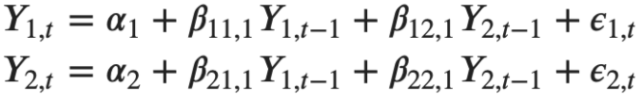  
Where, Y{1, t-1} and Y{2, t-1} are the first lag of time series Y1 and Y2 respectively. The above equations is referred to as a VAR(1) model because each equation is of order 1 (it contains up to one lag of each of the predictors (Y1 and and Y2). Since the Y terms in the equations are interrelated, the Y’s are considered as endogenous variables rather than as exogenous predictors. The second order VAR(2) model for two variables would include up to two lags for each variable (Y1 and Y2). 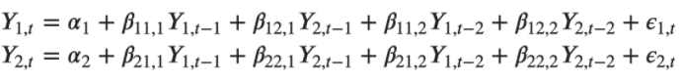  
As you increase the number of time series (variables) in the model, the system of equations become larger.